LOGICAL OPERATORS AND CONNECTIVES

Logical connectives - phrases or words which combine simple statements

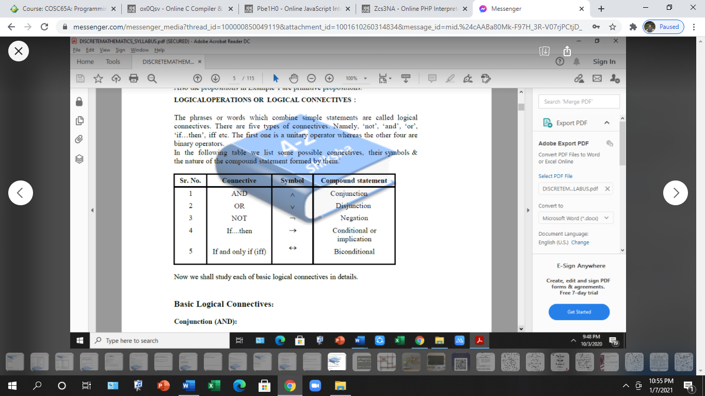There are 5 types of connectives:

Not

Or

If…then

If and only if (iff)

Basic logical connectives:

**Conjunction ( And )** – if two statements are combined by the word “and” to form a compound proposition then the resulting proposition is called the conjunction of two proposition

Symbolically, if P & Q are two simple statements , then ‘P Ʌ Q’ denotes conjunction of P and Q and is read as ‘P and Q

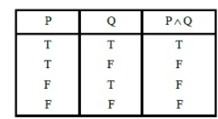

the truth table for conjunction is as follows :

**Disjunction (or)** – any two statements can be connected by the word ‘or’ to for a compound statement called disjunction.

Symbolically, if P and Q are two simple statements, the P ˅ Q denotes the disjunction of P and Q read as ‘P or ‘Q

The truth value of P ˅ Q depends only on the truth values of P and Q. Specifically if P and Q are false then P˅Q is false , otherwise P˅Q are is true.

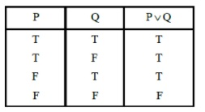

The truth table for disjunction is as follow :

**Negation (NOT) –** given any proposition P, another proposition , called negation of P, can be formed by modifying it by “not”. Also by using the phrase “it is not the case that or” “It is false that” before P we will be able to find the negation .  
  
symbolically, ¬P read as “not P” denotes the negation of P the truth value of ¬P depends on the truth value of P.

If P is true then ¬P is false.  
If P is false then ¬P is true.

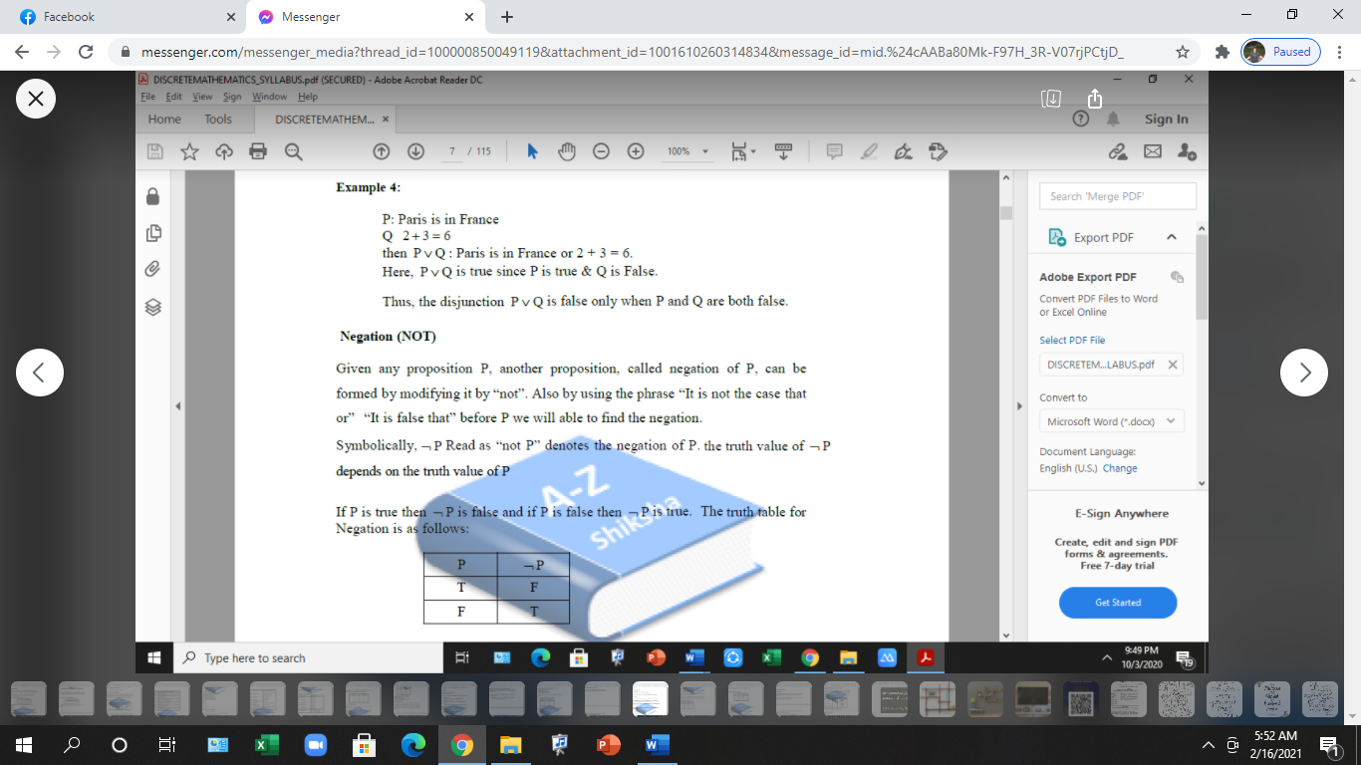

The truth table for negation is as follows:

**Conditional or Implication (If…then)**

If two statements are combined by using the logical connective ‘if…then’ then the resulting statement is called a conditional statement.

If P and Q are the two statement forming the implication ‘if P then Q’ then we denotes this implication P→Q.

In the implication P→Q.

P is called antecedent or hypothesis.

Q is called consequent or conclusion.

The statement P→Q is true in all cases except when P is true and Q is false.

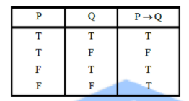

The truth table for implication is as follows.